Task 1.2

1. **Start using trello** 
   1. Trello is a card/list system where would have categories to list down cards under topical lists. These cards would have notes, further discussing what the cards are about.
      1. Current lists are:
         1. Ideas
            1. List of cards that have the ideas that we would want to incorporate to group work, in regards to anything in relevance to the project or group work
         2. Things to do
            1. Task that needed to be completed or re-submitted
         3. Doing
            1. Tasks that are currently being done by group members
         4. Roadblocks
            1. Notes of particular issues that can prevent us from progressing, or slow down the progress of the group
         5. Done
            1. A list of tasks that are completed and ready to submit
         6. Profiles
            1. List of notes pertaining to the individuals in the group which describes the individuals
         7. Files (initial use, but will use GitHub later)
            1. Uploaded files that will be later added to the file management systems after that has been organised
         8. Things that need to be improved
            1. A list of notes that list the aspects that are needed to be improved and fixed, so that there will be less interference with the progress of the group
         9. Progress review
            1. A review of how the group is running and progressing throughout the timeline. This is so that we can self-analyse ourselves and make improvements
2. **Explore trello** 
   1. Learning how to use the card system of trello and its functions
   2. Also using trello for its intended use (try not uploading files onto trello and use a management system)

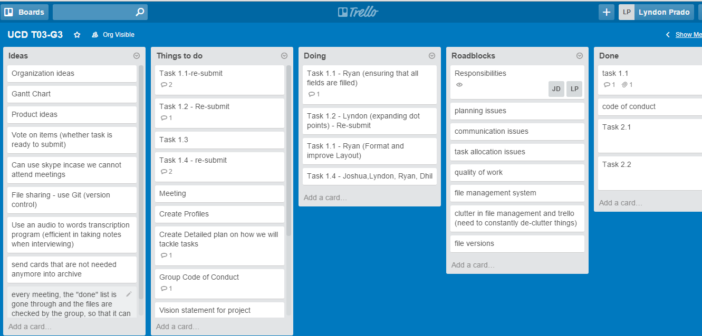

1. **Following lists in Trello (below are descriptions of the lists and what cards they would contain)**
   1. Ideas
      1. Organisation ideas
         1. Ideas that would be used to improve the management of the group, i.e. file management systems, such as using GitHub, and how we would collaborate
      2. Gantt chart
         1. Timeline of what tasks will be done and how we will organise ourselves to meet deadlines
   2. Things to do
      1. Task 1.1
         1. Purpose of this task was to determine the personality and work ethic of each member, so that we could determine how we could collaborate with each other
         2. Under this card, the task was initially assigned to Lyndon, to write down and brainstorm the profile and aspects of each group member
         3. Task was then passed over to Ryan to format and check over
      2. Task 1.2
         1. Purpose of this task was to explain how the group will manage themselves throughout the semester and the steps that would be taken for task management
         2. This task was done by Lyndon, and was reformatted by Lyndon as dot points were not enough (explanation for each was needed)
      3. Task 1.3
         1. This task is to fill out the details of the code of conduct which all members have to sign.
      4. Task 1.4
         1. The purpose of this task is to explain the scope of project, and the group will have to determine the user groups of the project and who we will be aiming for, with the product that we will have developed.
      5. Discuss on what tools to use to complete tasks
         1. Each week (in the meetings) we will discuss the equipment and procedure on how we will complete set tasks
      6. Create profiles for each group member on trello
         1. Need to compile a list of strengths and weaknesses and resources of team members so that we could contribute to the team.
      7. Must create a detailed plan on how we will tackle our weaknesses and what we will do to improve our performance
         1. This section will allow use other team member’s strengths and use it to help other team members with their weaknesses.
      8. Task management methods
         1. We will discuss management methods and make improvements
      9. Group communication methods and meeting time (a list on trello)
      10. Have pro’s and con’s of different methods of communication and ways of completing tasks
      11. Create a group code of conduct and get it signed by each member
   3. Doing list (currently doing)
   4. Roadblocks
      1. Other responsibilities
         1. FSAE Team – Lyndon
         2. Part time jobs
         3. Voluntary organisations
         4. Special consideration/needs
      2. Planning (improper planning)
      3. Communication
      4. Task allocation
      5. Quality of work
   5. Done
2. Determine how often we should be communicating
3. Consideration in peoples work load to determine the tasks that they are allocated
4. Discuss risk management

**Task management strategy**

* Weekly meetings
  + scrum
    - Talk about what group members have done the past week (related to group work)
    - Talk about the problems that they have faced whilst undertaking tasks
    - Brainstorm some improvements that can be made
  + Discussion
    - Things to do (for the coming week) – having due dates assigned to tasks
    - Look through the task that are done (as noted in trello) and go through each of the task that have been completed(by group members) and agree to submit it
    - Assign tasks for the week
    - Talks about any ideas that we have
    - Complete group tasks, such as conduct interviews, complete parts of task that need group work(in the meeting sessions) if it is necessary
    - See where we are at on the timeline of the Gantt chart
* Have a Gantt chart to explain what we will be doing every week
  + Rechecking so often to the if we are sticking to schedule, also have a comparison to the timeline in Doubtfire to see if we are sticking to schedule.
  + Having slack time
    - This slack time will allow us extra time to complete other tasks that are taking more longer to complete
  + Ensuring everyone is doing the work so that the work load is equal and no one has more pressure on finishing the tasks
  + Changing leadership so that if one group member has more work load, then someone else can take the load of the work of leadership
* Trello
  + Tasks allocated to other team members under the cards ( so that each team member knows what tasks they would have to compete)
  + Tasks that people are currently working on, so that other people know what tasks are being worked on and they can start other tasks.
* Time and distance for group members to travel to campus (7.1)
  + All team members live at least on hour away from Swinburne University, but Swinburne is central to all members. So as much as possible, trying to have as much autonomy between group members so that they can accomplish task on their own, because it will be more inconvenient for group members to constantly be travelling. Not only promoting Autonomy within group members, but also ensuring that team members work as a team when in meetings and together, and to get as much work done as much as possible.
* High workloads in other units (7.2)
  + Dhil is currently undertaking “Object oriented Programming” which requires a lot of work so it is understandable that he won’t be able to do that much work
  + Lyndon is currently undertaking the units “Robotic Control”, “Embedded Microcontrollers” and “Software Development for Mobile Devices”. Robotic control and Embedded Microcontrollers are both intensive and advance engineering subjects which require a lot of work, and Software Development for mobile Devices is also a heavy subject as it is a portfolio subject (portfolio subject usually require more work to be accomplished).
  + Josh has a project management subject that requires group work (just like this subject). Therefore also requires a lot of work for that subject
  + Ryan has networking subjects that can be heavy loads at some points
  + To compensate for this, heavy tasks are rotated on weeks that individuals have other demanding assignments, to team members that do not have that much assessments at that week.
* Paid work schedules (7.3)
  + Lyndon is volunteering for the Team Swinburne Formula Society of Automotive Engineers. This is not paid work, but is considered to be like a paid job. So this requires a lot of time and effort.
* Family responsibilities (7.4)
  + Lyndon has family activities during Saturdays and is not able to do any work.

**Documentation management methods**

* Use GitHub to manage files and its versions
  + GitHub will be used to store the files that have been produced by the group members. As people update each files, new versions will be created and older versions will be kept just in case a mistake is made. Once a mistake has been made to the file, it is possible to backtrack. The downside to using GitHub is that when 2 people are working on the same file at the same time then both people will not have each other’s versions. To fix this problem, a person will be assigned to check the 2 versions made by the 2 people, and combine the 2 versions together. This problem will seldom happen as different tasks are assigned to different team members so that they will most likely work on different files at one time. If there is group work needed for the tasks, which will promote multiple group members to adjust the same files at one time, then that’s when the person allocated will check the versions.
* Use slack to send files to other group members
  + This option will allow team members to check the files directly, and allows team members to make other team members to give importance to certain files they send through slack.
* Use trello to keep track of the tasks, what has been completed and what is ready to be submitted through Doubtfire
  + The cards that will be updated under the “done” list will allow team members to note the documents that are ready to be submitted. The file noted in the “done” list will be checked by all group members during the meeting to check for the quality of work and if it is ready to be submitted.

**Group communication methods**

* Common meeting time – 12:30 Monday (book a room in the library)
  + The team will conduct group meetings every week and conduct “Scrum”. This will allows us to see how the team is progressing and if there are any roadblocks that the team has faced during the past week
  + The meeting time will also allow the team to finalise certain documents needed to be submitted
  + The meeting will allow tasks to be assigned to team members
* Slack
  + Formal/industry based type communication (separates the social life from the professional life)
  + Allows team members to communicate with other team members with concerns that they have and also to make note if there any last minute changes
* Trello
  + Allows to make note of the important things to be done
  + Under the list “things that need to be improved” has cards that note the aspects, as a group, which needs to be improved. These cards consists of the feedback from the tutor, and also the opinions of the group itself
* How often will the group communicate
  + The amount of communication will fluctuate throughout different weeks, depending on other responsibilities of the team members, but the least amount of communication will be at least once a week, which is during the meeting. This is not to say that the group will only communicate once a week, and is encouraged to communicate through tools such as slack, as often as team members see fit, but as the weeks go by and team members become more busy, the amount of communication will be influenced to decrease, so therefore, the minimum level of communication will be once a week. Team members will be encouraged to check slack (on their phones through the application) frequently, as members may have concerns that need to be noted.

**Risk assessment on document management and communication**

* In trello we have a number of lists that have to do with risk assessment
  + Roadblocks
    - This list of cards explain the obstacles that we face on a week to week basis
    - It allows us to note the key problems that the group faces
  + Things that need to be improved
    - This list of cards is very similar to the “Roadblocks” list, the difference though is that this list tells us the feedback from the tutor on what we need to fix up, and also the feedback from team members, what we have discussed as a group to be improved upon.
  + Progress review
    - This list shows how far the group has progressed and if we have actually made some improvements in regards to the feedback that we have received.
* Risk in regards to task management
  + The team can get stuck in assigning tasks to each group member, because last minute changes can arise and the particular team member can become busy instantly
    - Solution: change leadership in the team so that the decision making is balanced and also take note of things that would make a team member more busy and discuss in the meetings so that tasks can be modified and assigned to someone else who has less work load
  + Other team members may view the assignment of the task as unfair and may reduce the morale of the team
    - Solution: have a voting system in the meetings so that it’s a majority vote, and will be considered fair by the majority of the team. This will reduce the level of bias.
  + The right tasks are not assigned properly
    - Solution: each team member will be encouraged to have the autonomy to point these issues out, because one team member alone may not be able to identify this. So as the task are assigned in the meetings, they can be adjusted during the week to compensate.
  + Team members might not do the task that they were assigned or they do not complete it to a high degree of quality
    - Solution: If a team member does not do the assigned work, the other team members will have to have a discussion with that particular person, to understand that he/she knows what he is doing, and explain the consequences of not completing the work. In the event that the person still intentionally decides to not do the task that was assigned, then consultation with the tutor may be used.
* Risk in regard to documentation
  + Files out of order
    - Solution: assign a team member to organise and declutter the files at least once a week
  + Files are not up to date
    - Solution: ensure that each member uploads their up to date version of their files to the file management system (in this case the team is using GitHub)
  + Files are not complete for submission resulting into a resubmit
    - Solution: check the quality of the file in the meeting (all team members) before submission.
  + Files being lost
    - Solution: check if there is any previous versions on the file management system, and in the worst case scenario, do the work again.
* Risk in regards to communication
  + Misunderstanding of other team members
    - Solution: each team member must give feedback to each team member on a regular basis, so that the team knows that they are on track.
  + Forgetting to let other team members know of certain things that are of importance.
    - Solution: write a list down of what you would like to let the other team members to know, that way you will have a reference when the item of importance is forgotten.
  + Not updating team members of how they are going with the tasks
    - Solution: meetings will be conducted every week, and if the team member has not updated the team as of yet, they will be asked in the meeting what they have worked on.
  + Unwillingness to communicate to each other
    - Solution: Use encouragement to allow the team member to be at ease when communicating. If they still refuse to communicate, they resolve it with the tutor